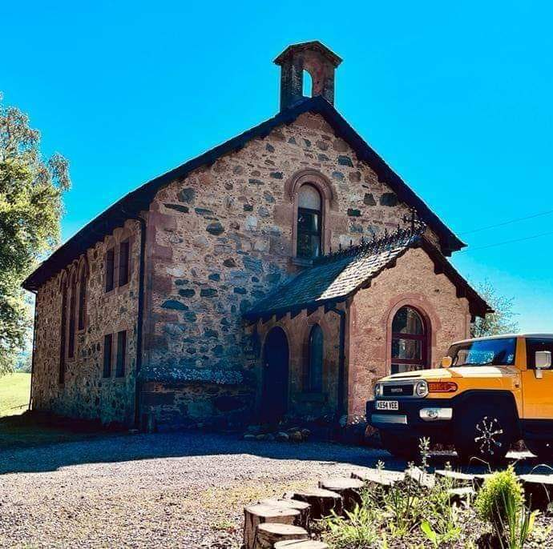

Welcome to HIGHFIELD HOUSE

We hope you have a good time here, and enjoy visiting the Highlands. The house is in fact a converted church, which was built in 1840 and closed a long time ago. It has a number of old features and considerable character.

The following notes are intended to help you familiarise with the accommodation/facilities and make your stay as enjoyable as possible. If you have any questions please don’t hesitate to ask. I can be contacted at any time on 07403 491317 or enquiries@welcometohighfieldhouse.com.

This is a home as well as holiday accommodation, so please try and leave it as you found it. If anything is lost or damaged please just let me know and this can be managed through the deposit scheme.

Highfield House is dog-friendly for up to two well- behaved dog. Dogs must remain downstairs during your stay and not be left unattended at any time.

Further information can be found on our website www.welcometohighfieldhouse.com

Neil Edwards

GENERAL

Heating and hot water - the property has an air- sourced heat pump for both central heating and hot water. This keeps water and the house at a constant temperature. There is a WiFi thermostat control for guests to use in the dining area recess, to set the indoor air temperature. Radiators in all rooms also have individual thermostat controls to set them as required.

Internet connection - Highfield House has fibre broadband internet access which is shared between guest and host accommodation. Speeds usually range from 10 – 14 mbs. The wi-fi password is XHeVrVJUc4eyRA and the internet network BT-ZPAKN2. It is adequate for web browsing and TV streaming.

There is a TV in the dining area and one in the upstairs games room (named Beauly). The TV sets are both connected to Amazon Fire TV Sticks.

Bed Linen – this is provided along with towels, bath mats and tea towels. There are summer and also winter down duvets provided at the house.

Kitchen – a wide selection of utensils and kitchen equipment is provided.

The vacuum cleaner is kept downstairs in the alcove by the front door.

Electricity Consumer Unit – this is located in the box in the alcove in the dining area. This is a modern RCD unit which detects any residual earth current leakage and prevents a fatal shock. If a switch on a particular circuit is triggered (e.g. by a light bulb failing), this can be re-set to the on position.

Smoking – the terms of insurance state that no smoking is allowed within the property. There are pots to put cigarette butts both within the enclosed garden and by the front door. Please don’t use candles or set off fireworks in the garden. We’d also ask that you don’t feed the horses over the fence in the garden. Thank you.

Bannisters: the conversion provides a large open staircase and upstairs gallery. Your attention is drawn to this in view of the heights involved – please make sure that no guests, especially children, try to slide down the bannister or lean against or over the rails.

DOWNSTAIRS

Vestibule – the entrance/vestibule provides a convenient place for leaving outdoor coats and footwear. Here muddy boots and shoes can be taken off and stored in the boot rack/shelving.

Toilet/Shower room - There is a shower room downstairs with shower, toilet and sink. Please ensure wipes of any kind or sanitary products are not flushed down the toilet, as this will damage and potentially break the water treatment tank causing immediate blocking of the waste pipes and will prevent the toilets from flushing.

Both the cloakroom and the bathroom have quirky taps – they turn the wrong way. It is very easy to leave them on if you automatically turn them as at home. Please try to check, in particular the hot taps!

Dining/Living area - there is a large dining area, and comfortable seating for relaxing, and also a bar barrel. A tablecloth is provided which protects against spills on the large table. Please could this be used to prevent stains/marks forming on the table.

Kitchen – this adjoins the dining area. The cooker has a large gas hob and two electric ovens and a grill. Bottled gas is used and the host asks that he be contacted immediately if the bottle needs changing. There is a dish- washer, and the washing machine and dryer are under the large work surface at the end of the kitchen. They are turned on by a master switch on the wall at the left. They are then controlled by switches on the machines themselves.

Please note that the dryer collects water in a reservoir at the top left of the machine. This needs to be emptied after each cycle and filter in the machine checked.

In case of any plumbing or water emergency, the cold water stopcock is located just behind back of the cooker on the left hand side. To turn this off, move the cooker and the small pipe cover box and the stop cock will be seen. This turns off all mains input to both the guest and host’s accommodation. So please speak with the host if there is a need to turn off water.

The host’s living accommodation is off a landing on the staircase. It is normally accessed through a back door when there are guests.

UPSTAIRS

Beauly - This is a games room where there is a seating area and large television, with table football as well. We hope you enjoy this space.
It also houses the linen cupboard and other storage.

Fortrose & Rosemarkie – this is the smaller of the double bedrooms. There is a chest of drawers/hanging space, a chair and side tables.

Cromarty – this is the bigger bedroom with a double bed, room for a travelling cot if required, a built-in wardrobe, a small desk, and a chair.

Avoch – this is a small room with a bunk bed with a desk where guests may like to work in peace and quiet.

Upstairs Bathroom – There is a stand- alone bath, shower, sink and toilet. Please ensure wipes of any kind or sanitary products are not flushed down the toilet, as this will damage and potentially break the water treatment tank causing immediate blocking of the waste pipes and will prevent the toilets from flushing.

OUTSIDE

There is an enclosed area with picket fence in the garden where children and dogs can be contained. This is a lawned area next to the building and facing south. It has a bench table. We do ask that when outside this area, all dogs remain on the lead and children be kept under close supervision. This is because the perimeter fencing around the property is not fully secure and we are next to a busy road and open fields with horses and sheep etc.

Guests have access to most of the garden, but not the rear, which is the host’s private area. This includes a dangerous drop to a lower level, with stonework which is not in good condition. It is fenced off. We kindly ask you to stay away from this area, and particularly keep children away. Obviously, if guests are renting the whole house they have access to all of the garden.

Parking for guests is found next to the lawn near the front entrance. There is space for 2-3 cars. The host’s car will be parked on the drive to the garage, so it’ll be out of your way.

USEFUL CONTACT DETAILS

Medical practice : Muir of Ord (Strathlene Surgery)
Pharmacies: Muir of Ord
Vet practice: Conon Bridge
Nearest station: Muir of Ord train half mile away
Buses: Bus stop by house (Dingwall/Inverness)
Small supermarkets: Two in Muir of Ord and one in Conon Bridge.
Mid Scot Coop - Beauly
Large supermarkets: Tesco in Dingwall and Coop in Beauly.

Cafes and Restaurants Nearby : Muir Hub cafe and restaurant, Khan Tandoori, Friary Fish & Chips in Beauly, Shimla Indian in Beauly, Corner on the Square ( Cafe & Deli) in Beauly. IV10 at Fortrose does extremely good food as does The Chanterelle Restaurant at Fortrose & Rosemarkie Golf Club.

Bunchrew House on The Beauly Firth offers romantic fine dining. This is highly recommended!

Household and Ironmongers, general store – Morisons in Beauly
Post Offices: Ord Garage and Spar; Conon Bridge, Beauly in large Coop.

TOURIST INFORMATION

Inverness has an excellent tourist information centre on the High Street. There are some leaflets in the house downstairs in the reception area that give plenty of information on attractions nearby.

The house website welcometohighfieldhouse.com has plenty of information as well.

EMERGENCY CONTACT DETAILS

If you need to contact me (Neil Edwards) for any reason, my number is 07403 491317 or enquiries@welcometohighfieldhouse.com

